**UNITED STATES**

**SECURITIES AND EXCHANGE COMMISSION**

**Washington, D.C. 20549**

___________________________

**FORM 8-K**

**CURRENT REPORT**

**Pursuant to Section 13 or 15(d) of the**

**Securities Exchange Act of 1934**

**Date of Report (Date of earliest event reported): July 17, 2025**

___________________________

**CNS Pharmaceuticals, Inc.**

(Exact name of registrant as specified in its charter)

___________________________

**Nevada**

(State or other jurisdiction of

**001-39126**

(Commission File Number)

**82-2318545**

(I.R.S. Employer Identification No.)

incorporation or organization)

**2100 West Loop South, Suite 900**

**Houston, Texas 77027**

(Address of principal executive offices) (Zip Code)

**Registrant’s telephone number, including area code: (800) 946-9185**

**Not Applicable**

(Former Name or Former Address, if Changed Since Last Report)

___________________________

Check the appropriate box below if the Form 8-K filing is intended to simultaneously satisfy the filing obligation of the registrant under any of the following provisions (*see* General Instruction A.2. below):

* Written communications pursuant to Rule 425 under the Securities Act (17 CFR 230.425)
* Soliciting material pursuant to Rule 14a-12 under the Exchange Act (17 CFR 240.14a-12)
* Pre-commencement communications pursuant to Rule 14d-2(b) under the Exchange Act (17 CFR 240.14d-2(b))
* Pre-commencement communications pursuant to Rule 13e-4(c) under the Exchange Act (17 CFR 240.13e-4(c))

Indicate by check mark whether the registrant is an emerging growth company as defined in Rule 405 of the Securities Act of 1933 (§230.405 of this chapter) or Rule 12b-2 of the Securities Exchange Act of 1934 (§240.12b-2 of this chapter).

Emerging growth company ☐

If an emerging growth company, indicate by check mark if the registrant has elected not to use the extended transition period for complying with any new or revised financial accounting standards provided pursuant to Section 13(a) of the Exchange Act. ☐

Securities registered pursuant to Section 12(b) of the Act:

|  |  |  |
| --- | --- | --- |
| Title of each class | Trading Symbols(s) | Name of each exchange on which registered |
| Common stock, par value $0.001 per share | CNSP | The NASDAQ Stock Market LLC |
|  |  |  |

**Item 3.03.** **Material Modification to Rights of Security Holders.**

The information set forth in Item 5.03 of this Current Report on Form 8-K is incorporated by reference into this Item 3.03. A copy of the Certificate of Change described in Item 5.03 is filed as Exhibit 3.1 to this Current Report on Form 8-K.

**Item 5.03.** **Amendments to Articles of Incorporation or Bylaws; Change in Fiscal Year.**

On July 17, 2025, CNS Pharmaceuticals, Inc., a Nevada corporation (the “Company”), filed with the Secretary of State of the State of Nevada a Certificate of Change (the “Certificate of Change”), pursuant to Nevada Revised Statutes 78.209, to effect a one-for-twelve (1-for-12) reverse stock split (the “Reverse Split”) of the Company’s issued and outstanding common stock, par value $0.001 per share (the “Common Stock”). The Reverse Split became effective as of 12:01 a.m. Eastern Time on July 22, 2025 (the “Effective Time”). Pursuant to the Nevada Revised Statutes 78.207, the Company’s board of directors has the authority to effect a reverse stock split without stockholder approval if the number of authorized shares of common stock and the number of outstanding shares of common stock are proportionally reduced.

As a result of the Reverse Split, each twelve pre-split shares of Common Stock outstanding was automatically combined into one new share of Common Stock without any action on the part of the holders. The number of authorized shares of common stock has been reduced from 300,000,000 to 25,000,000, while the number of authorized shares of preferred stock has been reduced from 5,000,000 to 416,667. The new CUSIP number for the Common Stock following the Reverse Split is 18978H508.

No fractional shares will be issued as a result of the Reverse Split. Stockholders who otherwise would be entitled to a fractional share because they hold a number of shares not evenly divisible by the 1-for-12 Reverse Split ratio will automatically be entitled to receive a cash payment in lieu of a fractional share. All of the Company’s current outstanding warrants to purchase shares of Common Stock and other derivatives automatically adjust per their terms to reflect the Reverse Split.

2



**Item 8.01.** **Other Events**

On July 18, 2025, the Company issued a press release announcing the Reverse Split. A copy of the press release is attached hereto as Exhibit 99.1 to this Current Report on Form 8-K and is incorporated herein by reference.

As of July 22, 2025, the Company had approximately 529,829 shares of Common Stock outstanding.

The table below sets forth the impact of the Reverse Stock Split on the Company’s net loss per common share – basic and diluted; weighted average common shares outstanding – basic and diluted; and shares issued and outstanding, for the years ended December 31, 2024 and 2023 and the three months ended March 31, 2025 and 2024:

|  |  |  |  |  |  |  |  |  |  |  |  |  |  |
| --- | --- | --- | --- | --- | --- | --- | --- | --- | --- | --- | --- | --- | --- |
|  |  | **PRE-SPLIT** | | | |  |  | **POST-SPLIT** | | | |  |  |
|  |  | **12 Months Ended** | | | |  |  | **12 Months Ended** | | | |  |  |
|  |  | **Dec 31, 2024** | |  | **Dec 31, 2023** |  |  | **Dec 31, 2024** | |  | **Dec 31, 2023** |  |  |
| **Net Loss** | **$** | **(14,857,801)** |  | **$** | **(18,851,226)** |  | **$** | **(14,857,801)** |  | **$** | **(18,851,226)** |  |  |
|  |  |  |  |  |  |  |  |  |  |  |  |  |  |
| **Shares Outstanding** |  |  |  |  |  |  |  |  |  |  |  |  |  |
| Basic |  | 382,241 | |  | 1,507 | |  | 31,854 | |  | 126 | |  |
| Diluted |  | 382,241 | |  | 1,507 | |  | 31,854 | |  | 126 | |  |
|  |  |  |  |  |  |  |  |  |  |  |  |  |  |
| **Loss per Share** |  |  |  |  |  |  |  |  |  |  |  |  |  |
| Basic | $ | (38.87) | | $ | (12,509.11) | | $ | (466.43) | | $ | (149,612.90) | |  |
| Diluted | $ | (38.87) | | $ | (12,509.11) | | $ | (466.43) | | $ | (149,612.90) | |  |
|  |  |  | | | |  |  |  | | | |  |  |
|  |  | **PRE-SPLIT** | | | |  | **POST-SPLIT** | | | |  |
|  |  | **3 Months Ended** | | | |  |  | **3 Months Ended** | | | |  |  |
|  |  | **Mar 31, 2025** | |  | **Mar 31, 2024** |  |  | **Mar 31, 2025** | |  | **Mar 31, 2024** |  |  |
| **Net Loss** | **$** | **(4,301,320)** |  | **$** | **(3,544,748)** |  | **$** | **(4,301,320)** |  | **$** | **(3,544,748)** |  |  |
|  |  |  |  |  |  |  |  |  |  |  |  |  |  |
| **Shares Outstanding** |  |  |  |  |  |  |  |  |  |  |  |  |  |
| Basic |  | 2,726,636 | |  | 3,474 | |  | 227,220 | |  | 290 | |  |
| Diluted |  | 2,726,636 | |  | 3,474 | |  | 227,220 | |  | 290 | |  |
|  |  |  |  |  |  |  |  |  |  |  |  |  |  |
| **Loss per Share** |  |  |  |  |  |  |  |  |  |  |  |  |  |
| Basic | $ | (1.58) | | $ | (1,020.36) | | $ | (18.93) | | $ | (12,223.27) | |  |
| Diluted | $ | (1.58) | | $ | (1,020.36) | | $ | (18.93) | | $ | (12,223.27) | |  |

3



|  |  |  |  |  |
| --- | --- | --- | --- | --- |
| **Item 9.01.** | **Financial Statements and Exhibits.** | | | |
| **No.** |  | **Description** | | |
| 3.1 |  | Certificate of Change | | |
|  |  |  |  |  |
| 99.1 |  | Press Release dated July 18, 2025 | |  |
| 104 |  | Cover Page Interactive Data File (embedded within the Inline XBRL document) | | |

4



**Signature**

Pursuant to the requirements of the Securities Exchange Act of 1934, the registrant has duly caused this report to be signed on its behalf by the undersigned hereunto duly authorized.

CNS Pharmaceuticals, Inc.

By: /s/ Chris Downs



Chris Downs

Chief Financial Officer

Dated: July 22, 2025

5



**Exhibit 3.1**

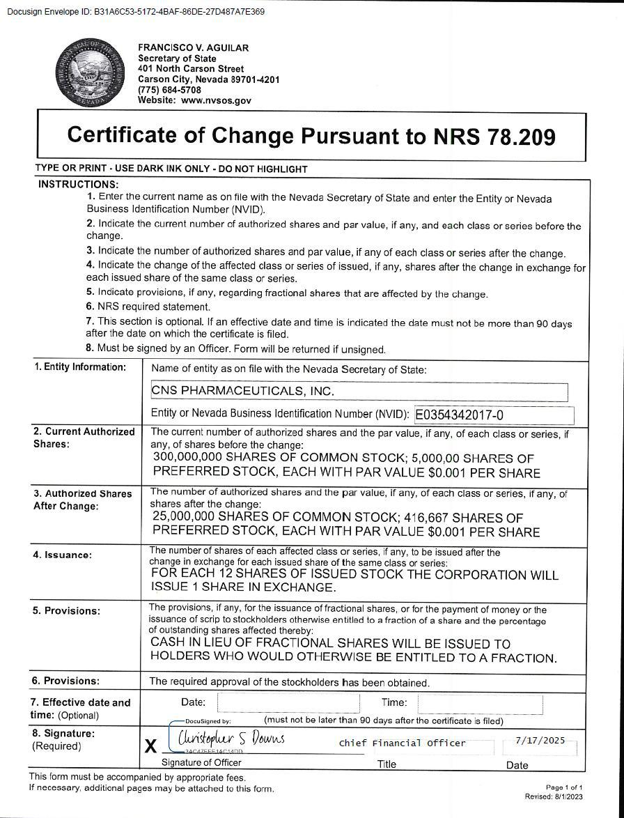

**Exhibit 99.1**



**CNS Pharmaceuticals Announces Reverse Stock Split**

**HOUSTON, TX (July 18, 2025) – CNS Pharmaceuticals, Inc. (NASDAQ: CNSP)** (“CNS” or the “Company”), a biopharmaceutical companyspecializing in the development of novel treatments for primary and metastatic cancers in the brain and central nervous system, today announced a 1-for-12 reverse split of its common stock. Beginning on July 22, 2025, the Company’s common stock will continue to trade on The Nasdaq Capital Market (“Nasdaq”) on a split adjusted basis under the trading symbol “CNSP” but will trade under the following new CUSIP number: 18978H508.

As a result of the reverse stock split, every 12 shares of common stock issued and outstanding as of the effective date will be automatically combined into one share of common stock. Outstanding warrants, equity-based awards and other outstanding equity rights will be proportionately adjusted by dividing the shares of common stock underlying the securities by 12 and multiplying the exercise/conversion price, as the case may be, by 12. No fractional shares will be issued if, as a result of the reverse stock split, a stockholder would otherwise become entitled to a fractional share because the number of shares of common stock they hold before the reverse stock split is not evenly divisible by the split ratio. Instead, each stockholder will be entitled to receive a cash payment in lieu of a fractional share. The par value of the common stock will remain unchanged at $0.001 per share after the reverse split. The number of authorized shares of common stock will be proportionately reduced to 25 million shares. The reverse split affects all stockholders uniformly and will not alter any stockholder’s percentage interest in the Company’s equity, except to the extent that the reverse split results in some stockholders owning a fractional share as described above.

**About CNS Pharmaceuticals, Inc.**

CNS Pharmaceuticals is a clinical-stage pharmaceutical company developing a pipeline of anti-cancer drug candidates for the treatment of primary and metastatic cancers of the brain and central nervous system.

The Company's drug candidate TPI 287 is an abeotaxane, which stabilizes microtubules and inhibits cell division, causing apoptosis and cell death. The initial clinical efficacy data suggest TPI 287 has the potential to cross the blood-brain barrier and treat CNS tumors. TPI 287 also has been tested in over 350 patients in clinical trials as a monotherapy and in combination with bevacizumab for the treatment of a range of diseases or conditions, including recurrent glioblastoma, recurrent neuroblastoma and medulloblastoma, advanced malignancies, advanced unresectable pancreatic cancer, metastatic melanoma, and breast cancer metastatic to the brain. To date TPI 287 appears have both an excellent safety profile and high tolerability among patients.

For more information, please visit www.CNSPharma.com, and connect with the Company on X, Facebook, and LinkedIn.

**Forward-Looking Statements**

Some of the statements in this press release are forward-looking statements within the meaning of Section 27A of the Securities Act of 1933, Section 21E of the Securities Exchange Act of 1934 and the Private Securities Litigation Reform Act of 1995, which involve risks and uncertainties. Forward-looking statements in this press release include, without limitation, the timing and completion of the reverse split. These statements relate to future events, future expectations, plans and prospects. Although CNS believes the expectations reflected in such forward-looking statements are reasonable as of the date made, expectations may prove to have been materially different from the results expressed or implied by such forward-looking statements. CNS has attempted to identify forward-looking statements by terminology including ''believes,'' ''estimates,'' ''anticipates,'' ''expects,'' ''plans,'' ''projects,'' ''intends,'' ''potential,'' ''may,'' ''could,'' ''might,'' ''will,'' ''should,'' ''approximately'' or other words that convey uncertainty of future events or outcomes to identify these forward-looking statements. These statements are only predictions and involve known and unknown risks, uncertainties and other factors, including those discussed under Item 1A. "Risk Factors" in CNS's most recently filed Form 10-K filed with the Securities and Exchange Commission ("SEC") and updated from time to time in its Form 10-Q filings and in its other public filings with the SEC. Any forward-looking statements contained in this press release speak only as of its date. CNS undertakes no obligation to update any forward-looking statements contained in this press release to reflect events or circumstances occurring after its date or to reflect the occurrence of unanticipated events.

**CONTACTS:**

**Investor Relations Contact**

JTC Team, LLC

Jenene Thomas

908.824.0775

CNSP@jtcir.com