UNITED STATES

SECURITIES AND EXCHANGE COMMISSION

Washington, D.C. 20549

___________________________

FORM 8-K

CURRENT REPORT

Pursuant to Section 13 or 15(d) of the

Securities Exchange Act of 1934

Date of Report (Date of earliest event reported): June 3, 2024

___________________________

CNS Pharmaceuticals, Inc.

(Exact name of registrant as specified in its charter)

___________________________

Nevada

(State or other jurisdiction of

001-39126

(Commission File Number)

82-2318545

(I.R.S. Employer Identification No.)

incorporation or organization)

2100 West Loop South, Suite 900

Houston, Texas 77027

(Address of principal executive offices) (Zip Code)

Registrant’s telephone number, including area code: (800) 946-9185

Not Applicable

(Former Name or Former Address, if Changed Since Last Report)

___________________________

Check the appropriate box below if the Form 8-K filing is intended to simultaneously satisfy the filing obligation of the registrant under any of the following provisions (see General Instruction A.2. below):

- Written communications pursuant to Rule 425 under the Securities Act (17 CFR 230.425)

- Soliciting material pursuant to Rule 14a-12 under the Exchange Act (17 CFR 240.14a-12)

- Pre-commencement communications pursuant to Rule 14d-2(b) under the Exchange Act (17 CFR 240.14d-2(b))

- Pre-commencement communications pursuant to Rule 13e-4(c) under the Exchange Act (17 CFR 240.13e-4(c))

Indicate by check mark whether the registrant is an emerging growth company as defined in Rule 405 of the Securities Act of 1933 (§230.405 of this chapter) or Rule 12b-2 of the Securities Exchange Act of 1934 (§240.12b-2 of this chapter).

Emerging growth company ☒

If an emerging growth company, indicate by check mark if the registrant has elected not to use the extended transition period for complying with any new or revised financial accounting standards provided pursuant to Section 13(a) of the Exchange Act. ☐

Securities registered pursuant to Section 12(b) of the Act:

Title of each class | Trading Symbols(s) | Name of each exchange on which registered
Common stock, par value $0.001 per share | CNSP | The NASDAQ Stock Market LLC

Item 3.03. Material Modifications of Rights of Security Holders.

To the extent required by Item 3.03 of Form 8-K, the information contained in Item 5.03 herein is incorporated by reference into this Item 3.03.

Item 5.03. Amendments to Articles of Incorporation or Bylaws; Change in Fiscal Year.

At the CNS Pharmaceuticals, Inc. (the “Company”) annual meeting of stockholders held on April 30, 2024, the stockholders of the Company approved an amendment to the Company’s amended and restated articles of incorporation (the “Amendment”) to effect the reverse stock split at a ratio in the range of 1-for-2 to 1-for-50, with such ratio to be determined in the discretion of the Company’s board of directors and with such reverse stock split to be effected at such time and date, if at all, as determined by the Company’s board of directors in its sole discretion prior to the one-year anniversary of the annual meeting.

Pursuant to such authority granted by the Company’s stockholders, the Company’s board of directors approved a one-for-fifty (1:50) reverse stock split (the “Reverse Stock Split”) of the Company’s common stock and the filing of the Amendment to effectuate the Reverse Stock Split. The Amendment was filed with the Secretary of State of the State of Nevada and the Reverse Stock Split became effective in accordance with the terms of the Amendment at 4:01 p.m. Eastern Time on June 4, 2024 (the “Effective Time”). The Amendment provides that, at the Effective Time, every fifty shares of the Company’s issued and outstanding common stock will automatically be combined into one issued and outstanding share of common stock, without any change in par value per share, which will remain $0.001.

As a result of the Reverse Stock Split, the number of shares of common stock outstanding will be reduced from approximately 16.25 million shares as of June 4, 2024 to approximately 325 thousand shares, and the number of authorized shares of common stock will remain at 300 million shares. As a result of the Reverse Stock Split, proportionate adjustments will be made to the per share exercise price and/or the number of shares issuable upon the exercise or vesting of all outstanding stock options, restricted stock unit awards and warrants, which will result in a proportional decrease in the number of shares of the Company’s common stock reserved for issuance upon exercise or vesting of such stock options, restricted stock unit awards and warrants, and, in the case of stock options and warrants, a proportional increase in the exercise price of all such stock options and warrants. In addition, the number of shares reserved for issuance under the Company’s equity compensation plan immediately prior to the Effective Time will be reduced proportionately.

No fractional shares will be issued as a result of the Reverse Stock Split. Stockholders of record who would otherwise be entitled to receive a fractional share will be entitled to the rounding up of the fractional share to the nearest whole number. The Reverse Stock Split became effective at 4:01 p.m., Eastern Time, on June 4, 2024, and the Company’s common stock is expected to begin trading on a Reverse Stock Split-adjusted basis on The Nasdaq Capital Market at the open of the markets on June 5, 2024. The trading symbol for the common stock will remain “CNSP.” The Company’s post-Reverse Stock Split common stock has a new CUSIP number (CUSIP No. 18978H300), but the par value and other terms of the common stock are not affected by the Reverse Stock Split.

The summary of the of Amendment does not purport to be complete and is qualified in its entirety by reference to the full text of the Amendment, a copy of which is attached hereto as Exhibit 3.1 and is incorporated herein by reference.

2

Item 8.01. Other Events.

On June 3, 2024, the Company issued a press release to announce that today it filed a certificate of amendment to its articles of incorporation with the Secretary of State of the State of Nevada to effect a 1-for-50 reverse stock split of its common stock. A copy of the press release is attached to this report as Exhibit 99.1 and is incorporated by reference herein.

The table below sets forth the impact of the Reverse Stock Split on the Company’s net loss per common share – basic and diluted; weighted average common shares outstanding – basic and diluted; and shares issued and outstanding, for the years ended December 31, 2023 and 2022; the three months ended March 31, 2024 and 2023:

 |  |  |  |  |  | PRE-SPLIT |  |  |  |  |  | POST-SPLIT
 |  |  |  |  |  | 12 Months Ended |  |  |  |  |  | 12 Months Ended
 |  |  |  |  | Dec 31, 2023 |  |  |  | Dec 31, 2022 |  |  | Dec 31, 2023 |  |  | Dec 31, 2022
Net Loss |  |  | $ |  | (18,851,226) |  |  | $ | (15,274,134) |  | $ | (18,851,226) |  | $ | (15,274,134)
Shares Outstanding
Basic |  |  |  |  | 3,767,372 |  |  |  | 1,361,737 |  |  | 75,348 |  |  | 27,235
Diluted |  |  |  |  | 3,767,372 |  |  |  | 1,361,737 |  |  | 75,348 |  |  | 27,235
Loss per Share
Basic | $ |  |  |  | (5.00) |  |  | $ | (11.22) |  | $ | (250.19) |  | $ | (560.83)
Diluted | $ |  |  |  | (5.00) |  |  | $ | (11.22) |  | $ | (250.19) |  | $ | (560.83)
 |  |  |  |  |  | PRE-SPLIT |  |  |  |  |  | POST-SPLIT
 |  |  |  |  |  | 3 Months Ended |  |  |  |  |  | 3 Months Ended
 |  |  |  |  | Mar 31, 2024 |  |  |  | Mar 31, 2023 |  |  | Mar 31, 2024 |  |  | Mar 31, 2023
Net Loss |  |  | $ |  | (3,544,748) |  |  | $ | (4,931,947) |  | $ | (3,544,748) |  | $ | (4,931,947)
Shares Outstanding
Basic |  |  |  |  | 8,712,680 |  |  |  | 1,906,494 |  |  | 174,254 |  |  | 38,130
Diluted |  |  |  |  | 8,712,680 |  |  |  | 1,906,494 |  |  | 174,254 |  |  | 38,130
Loss per Share
Basic | $ |  |  |  | (0.41) |  |  | $ | (2.59) |  | $ | (20.34) |  | $ | (129.35)
Diluted | $ |  |  |  | (0.41) |  |  | $ | (2.59) |  | $ | (20.34) |  | $ | (129.35)
Item 9.01. | Financial Statements and Exhibits
(d) Exhibits
Exhibit No. |  | Exhibit Description
3.1 |  | Certificate of Amendment to the Amended and Restated Articles of Incorporation of CNS Pharmaceuticals, Inc., filed with the
 |  | Secretary of State of the State of Nevada.
99.1 |  | Press Release dated June 3, 2024

- Cover page Interactive Data File (embedded within the Inline XBRL document)

3

Signature

Pursuant to the requirements of the Securities Exchange Act of 1934, the registrant has duly caused this report to be signed on its behalf by the undersigned hereunto duly authorized.

CNS Pharmaceuticals, Inc.

By: /s/ Chris Downs

Chris Downs

Chief Financial Officer

Dated: June 5, 2024

4

Exhibit 3.1
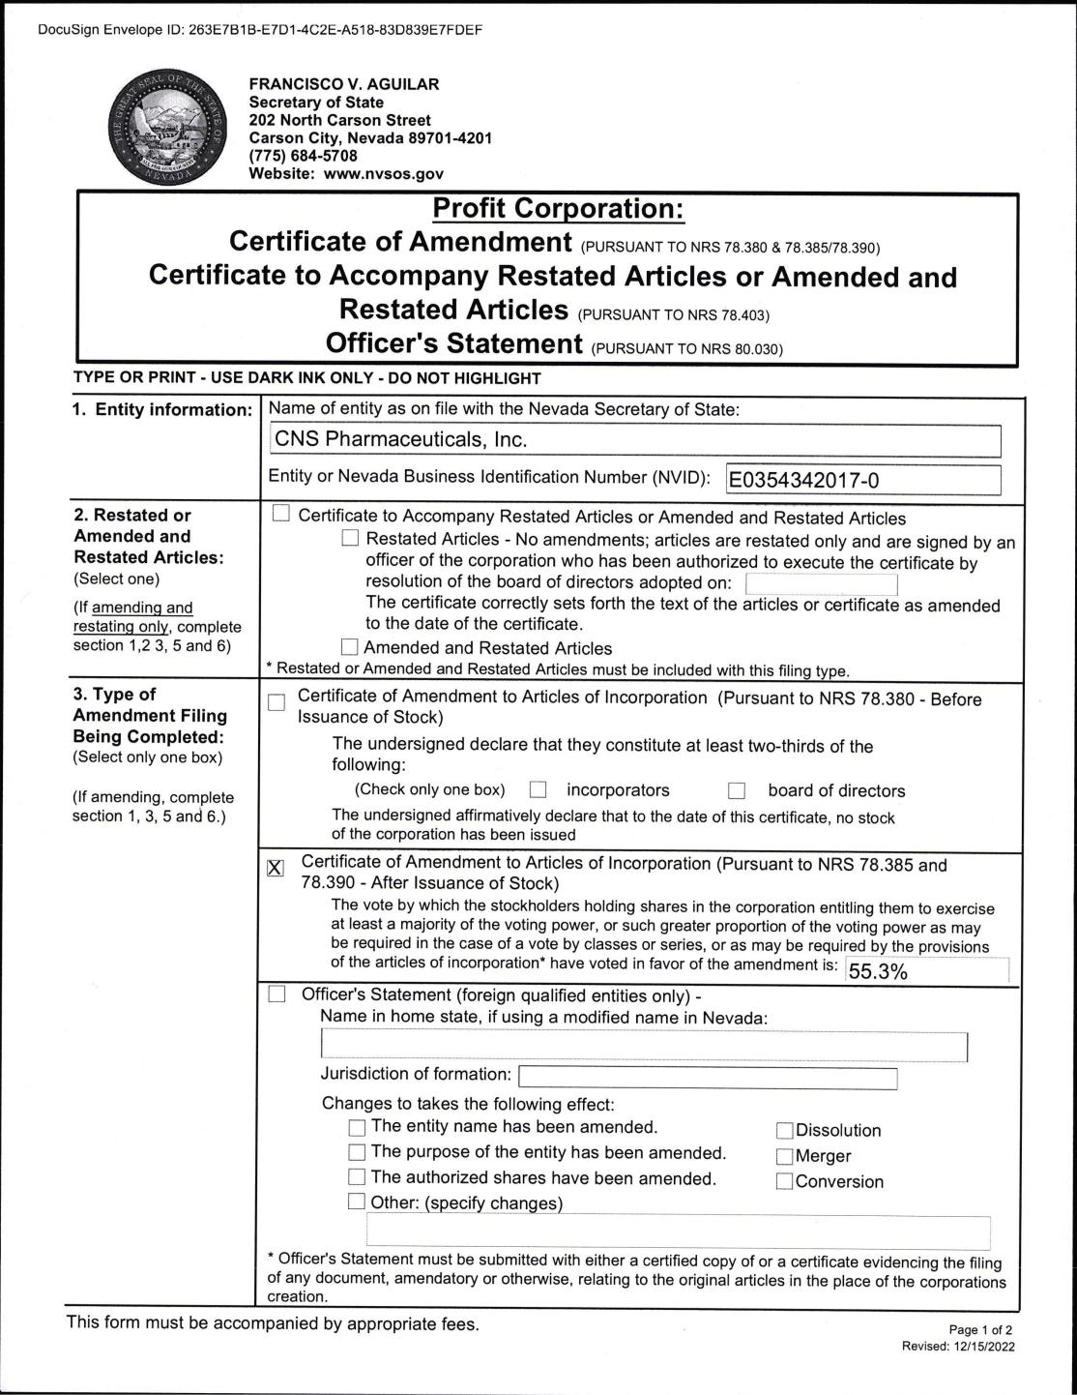

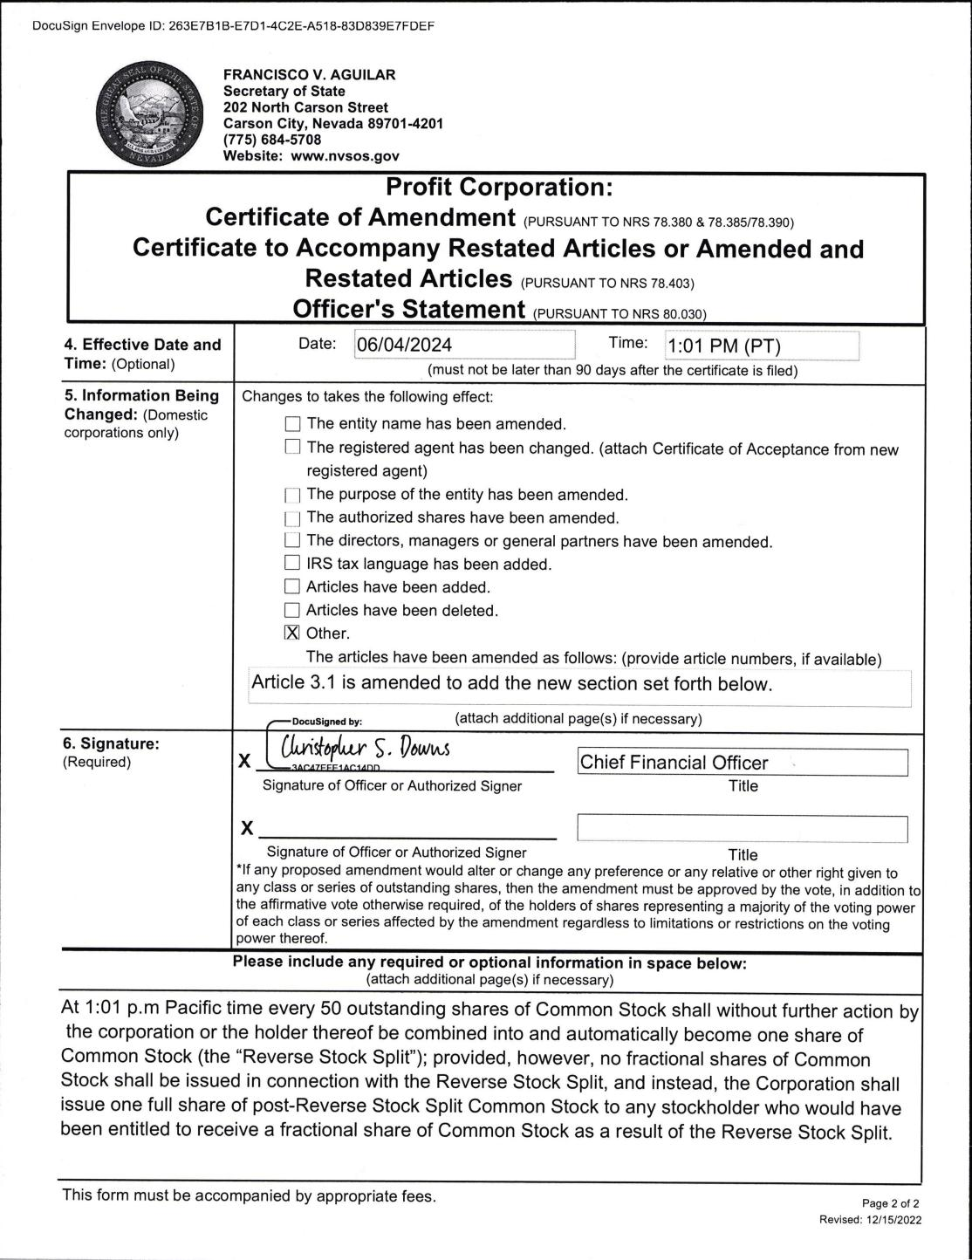

Exhibit 99.1

CNS Pharmaceuticals Announces Reverse Stock Split

HOUSTON, TX (June 3, 2024) – CNS Pharmaceuticals, Inc. (NASDAQ: CNSP) (“CNS” or the “Company”), a biopharmaceutical company specializing in the development of novel treatments for primary and metastatic cancers in the brain and central nervous system, today announced a 1-for-50 reverse split of its common stock, effective at 4:01 PM ET on June 4, 2024. Beginning on June 5, 2024, the Company’s common stock will continue to trade on The Nasdaq Capital Market (“Nasdaq”) on a split adjusted basis under the trading symbol “CNSP”, but will trade under the following new CUSIP number: 18978H300. The reverse stock split is primarily intended to increase the Company’s per share trading price and bring the Company into compliance with the Nasdaq’s listing requirement regarding minimum share price.

As a result of the reverse stock split, every 50 shares of common stock issued and outstanding as of the effective date will be automatically combined into one share of common stock. Outstanding warrants, equity-based awards and other outstanding equity rights will be proportionately adjusted by dividing the shares of common stock underlying the securities by 50 and multiplying the exercise/conversion price, as the case may be, by 50. No fractional shares will be issued as a result of the reverse stock split. Stockholders of record who would otherwise be entitled to receive a fractional share will be entitled to the rounding up of the fractional share to the nearest whole number. The par value of the common stock will remain unchanged at $0.001 per share after the reverse split, and the number of authorized shares of common stock will remain at 300 million shares. The reverse split affects all stockholders uniformly and will not alter any stockholder’s percentage interest in the Company’s equity, except to the extent that the reverse split results in some stockholders owning a fractional share as described above.

About CNS Pharmaceuticals, Inc.

CNS Pharmaceuticals a clinical-stage pharmaceutical company developing a pipeline of anti-cancer drug candidates for the treatment of primary and metastatic cancers of the brain and central nervous system. The Company’s lead drug candidate, Berubicin, is a novel anthracycline and the first anthracycline to appear to cross the blood-brain barrier. Berubicin is currently in development for the treatment of a number of serious brain and CNS oncology indications including glioblastoma multiforme (GBM), an aggressive and incurable form of brain cancer.

For more information, please visit www.CNSPharma.com, and connect with the Company on Twitter, Facebook, and LinkedIn.

Forward-Looking Statements

Some of the statements in this press release are forward-looking statements within the meaning of Section 27A of the Securities Act of 1933, Section 21E of the Securities Exchange Act of 1934 and the Private Securities Litigation Reform Act of 1995, which involve risks and uncertainties. Forward-looking statements in this press release include, without limitation, the timing and completion of the reverse split. These statements relate to future events, future expectations, plans and prospects. Although CNS believes the expectations reflected in such forward-looking statements are reasonable as of the date made, expectations may prove to have been materially different from the results expressed or implied by such forward-looking statements. CNS has attempted to identify forward-looking statements by terminology including ''believes,'' ''estimates,'' ''anticipates,'' ''expects,'' ''plans,'' ''projects,'' ''intends,'' ''potential,'' ''may,'' ''could,'' ''might,'' ''will,'' ''should,'' ''approximately'' or other words that convey uncertainty of future events or outcomes to identify these forward-looking statements. These statements are only predictions and involve known and unknown risks, uncertainties and other factors, including those discussed under Item 1A. "Risk Factors" in CNS's most recently filed Form 10-K filed with the Securities and Exchange Commission ("SEC") and updated from time to time in its Form 10-Q filings and in its other public filings with the SEC. Any forward-looking statements contained in this press release speak only as of its date. CNS undertakes no obligation to update any forward-looking statements contained in this press release to reflect events or circumstances occurring after its date or to reflect the occurrence of unanticipated events.

CONTACTS:

Investor Relations Contact

JTC Team, LLC

Jenene Thomas

833-475-8247

CNSP@jtcir.com

